**aRobot Operating System (ROS) - Installation Instructions**

**Used Settings:**

* Operating System = Debian 9.3 (Stretch) 64-bit
* ROS Version = Lunar Loggerhead

**Step 1)** Install Virtual Machine (VirtualBox)

1.1) Download Oracle VM VirtualBox (Pay attention to your OS type).

* <https://www.virtualbox.org/wiki/Downloads>

1.2) Install Oracle VM VirtualBox.

* <https://www.virtualbox.org/manual/ch01.html#intro-installing>

1.3) Create New Virtual Machine.

* <https://www.virtualbox.org/manual/ch01.html#gui-createvm>

(Recomended Settings: Processor=2CPUs / RAM=2GB / HD=16GB / Video=128MB)

1.4) Download Debian 9.3 Stretch (64-bit).

* <https://www.debian.org/distrib/netinst> (amd64)

1.5) Insert the Debian 9.3 Disk Image and Start the Virtual Machine.

1.6) Install Debian 9.3 Stretch (64-bit) (Note: Internet Connection is Required!).

* Note: Install “GNOME Desktop” and GRUB.

**Step 2)** Install ROS Lunar Loggerhead (for Debian amd64).

<http://wiki.ros.org/lunar/Installation/Debian>

**For Getting sensor from arduino:**

apt-get update

apt-get upgrade

Apt-get install sudo

Sudo adduser sparty sudo

Nano /etc/sudoers

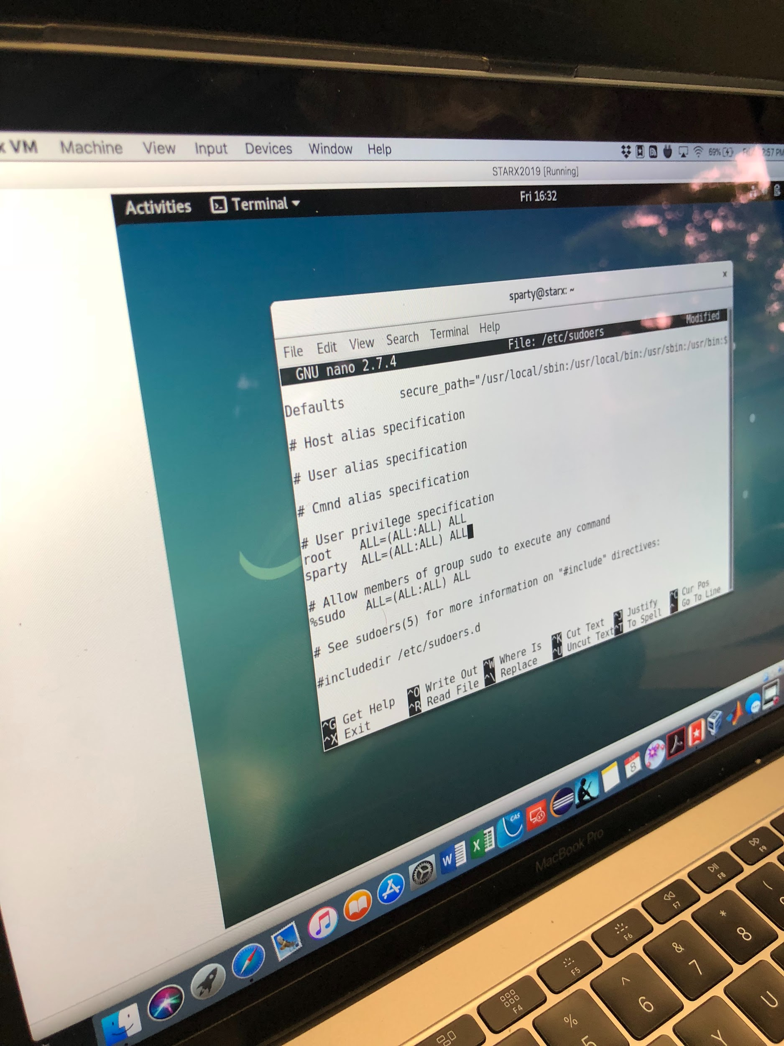

Above add the:

Root ALL=(ALL:ALL) ALL

Sparty ALL=(ALL:ALL) ALL

Exit

Sudo apt-get update

Sudo apt-get install module-assistant build-essential

Su (go into root user)

m-a prepare

cd ..

cd ..

Ls

mount media/cdrom

sh /media/cdrom/VBoxLinuxAdditions.run

Restart VB (manual or through terminal)

Go to menu bar at the top of the window and click devices>shared-clipboard>bidirectional

(Now you can go to full screen and copy and paste between host machine and virtual box)

Download atom from firefox (.deb)

cd Downloads/

Ls (to see if atom is there)

Sudo apt-get -f install

sudo dpkg -r atom

sudo dpkg -i atom-amd64.deb

To max/min windows go to tweak settings by searching Tweak

From the google drive download the firmware and all arduino python codes

Sudo apt-get install python-pip

Pip install pyserial

Sudo apt-get install python-serial

Sudo import serial

Sudo groups dialout <username>

reload/researt VD

Ctrl + \ to end programs

**To run the program:**

cd Documents/

Python sensordata_time.py

Sudo usermod

End program

The data sheet will be overwritten every time the program is ran unless the csv is saved under a new name.

The csv that the data is collected onto can be opened after the program is ended under the name: sensor_data.csv

**Change 32 bit vitrualbox to allow 64 bit as long as host PC is 64bit compatible.**

<http://www.fixedbyvonnie.com/2014/11/virtualbox-showing-32-bit-guest-versions-64-bit-host-os/#.Wx6Buy--LfY>

On the PC the virtualization was disabled, just enable it and that should be enough.